Project Development Phase Delivery of Sprint-1

|  |  |
| --- | --- |
| Team ID | PNT2022TMID32509 |
| Project Name | Retail Store Stock Inventory  Analytics |

**Project Development Phase: Sprint-1:**

# Data Collection

* Data Preparation **Sprint-2:**
* Data Exploration **Sprint-3:**
* Dashboard Creation **Sprint-4:**

# Report Creation

* Story Creation

Sprint-1:

Data Collection:

Download the Dataset

Dataset link - https://rb.gy/mepmp0

Load the Dataset:

Tool used – IBM Cognos

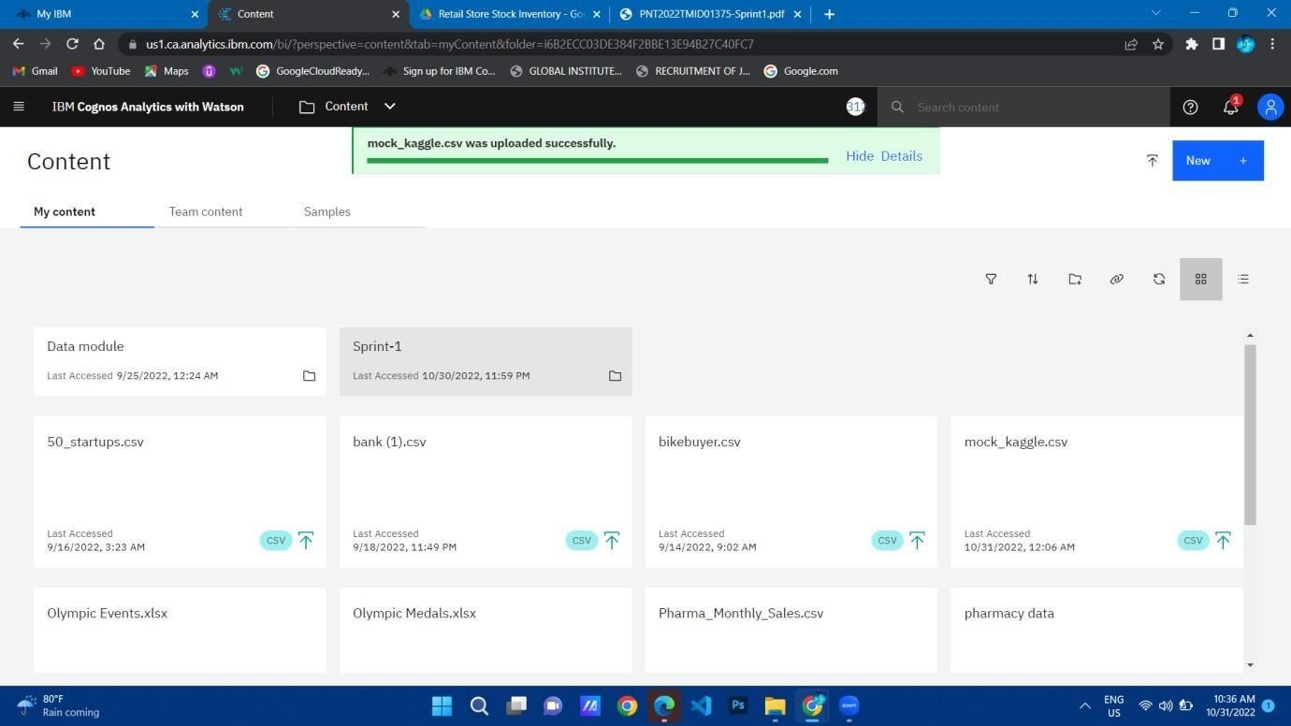

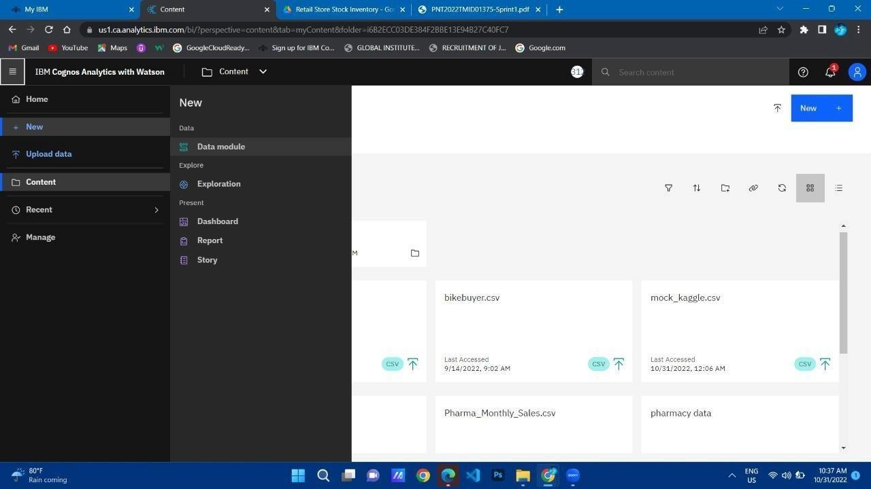

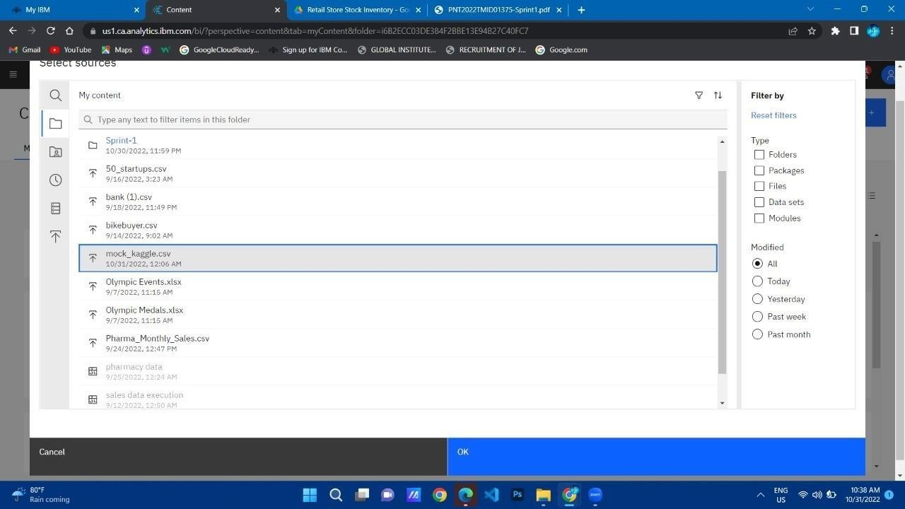

Month data:

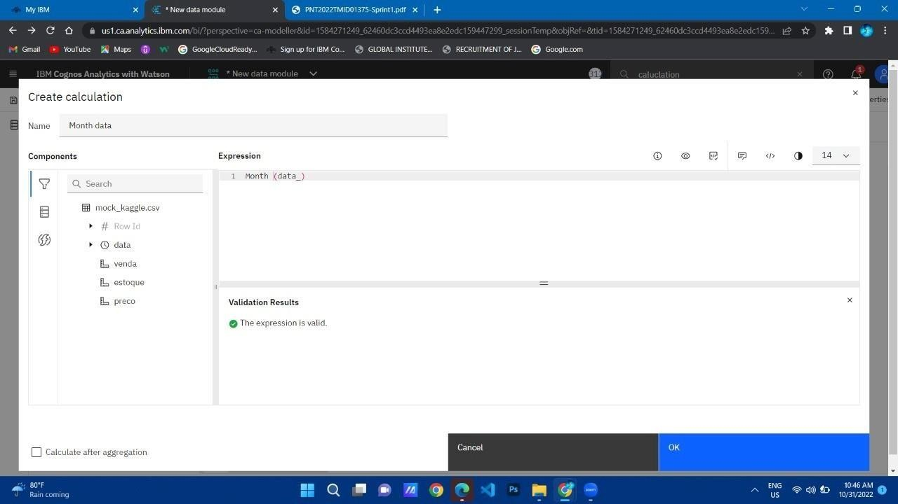

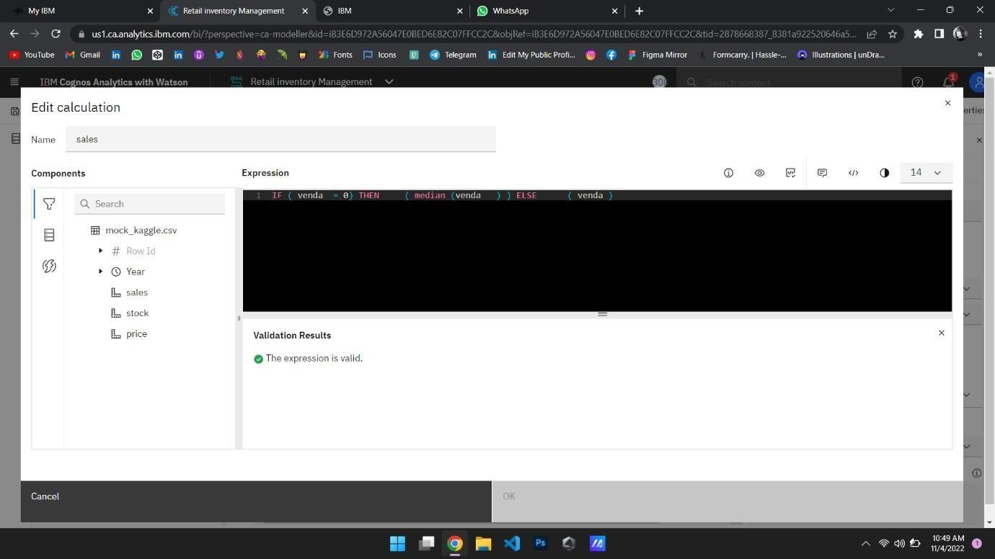

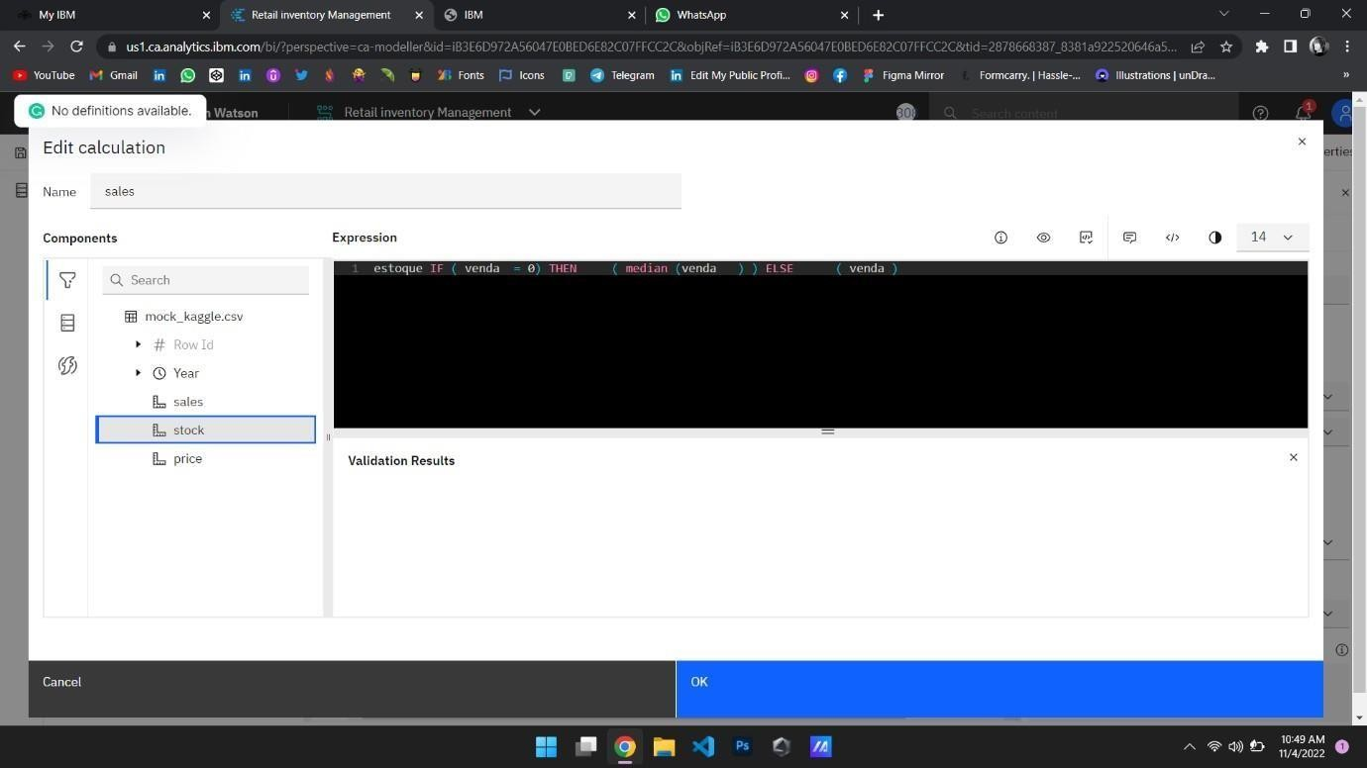

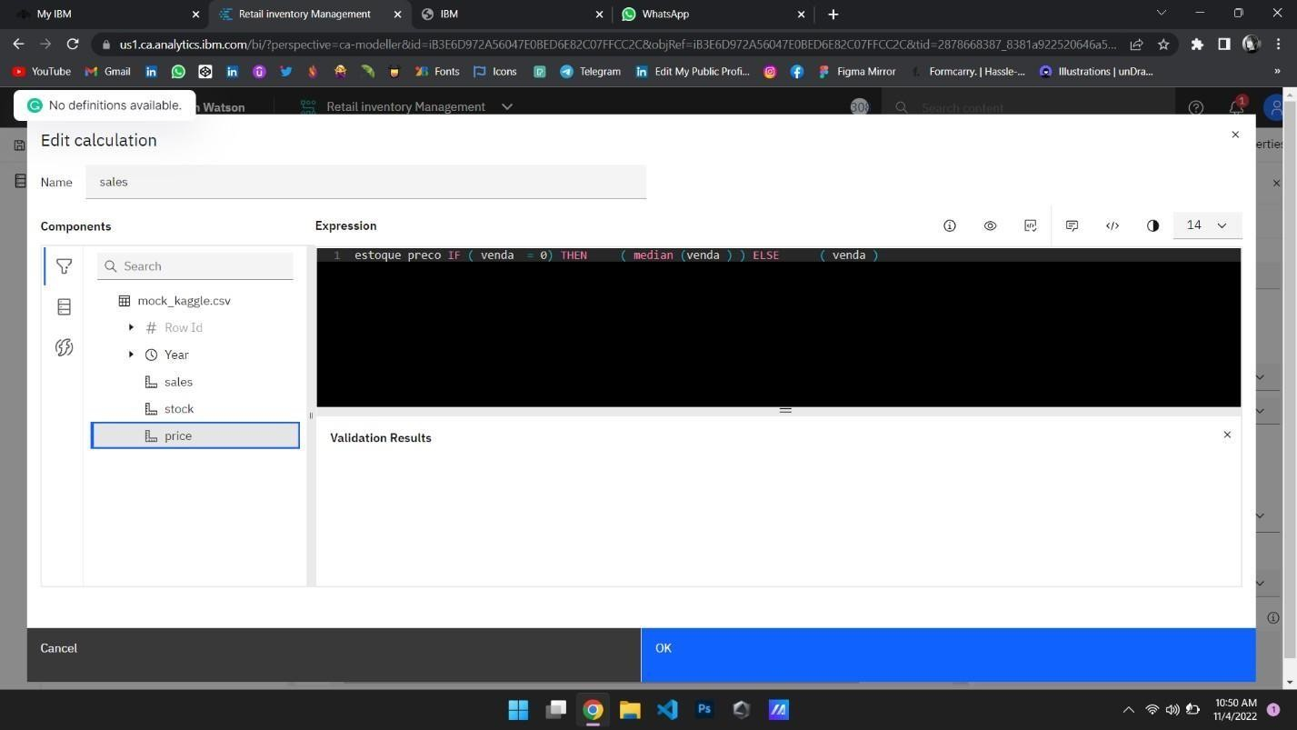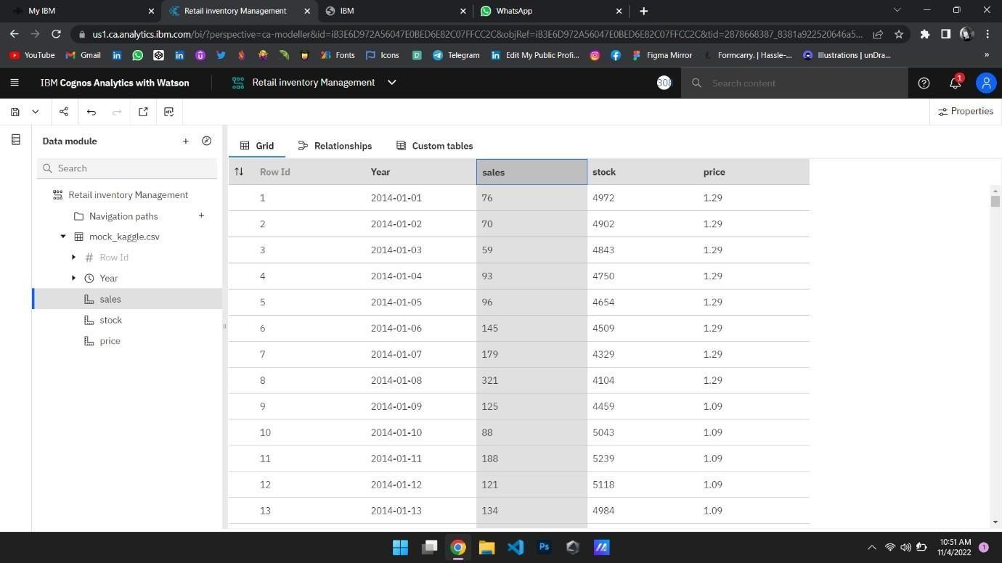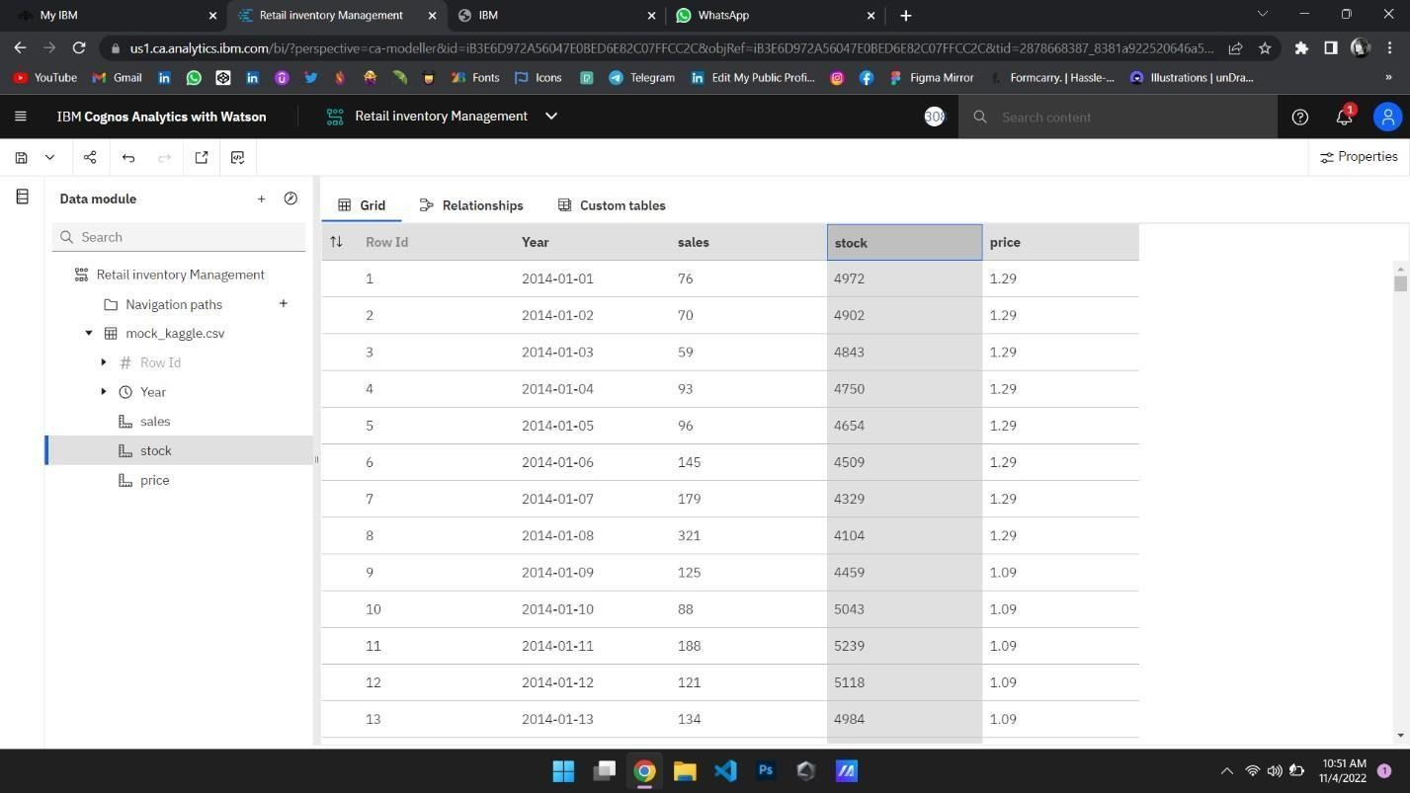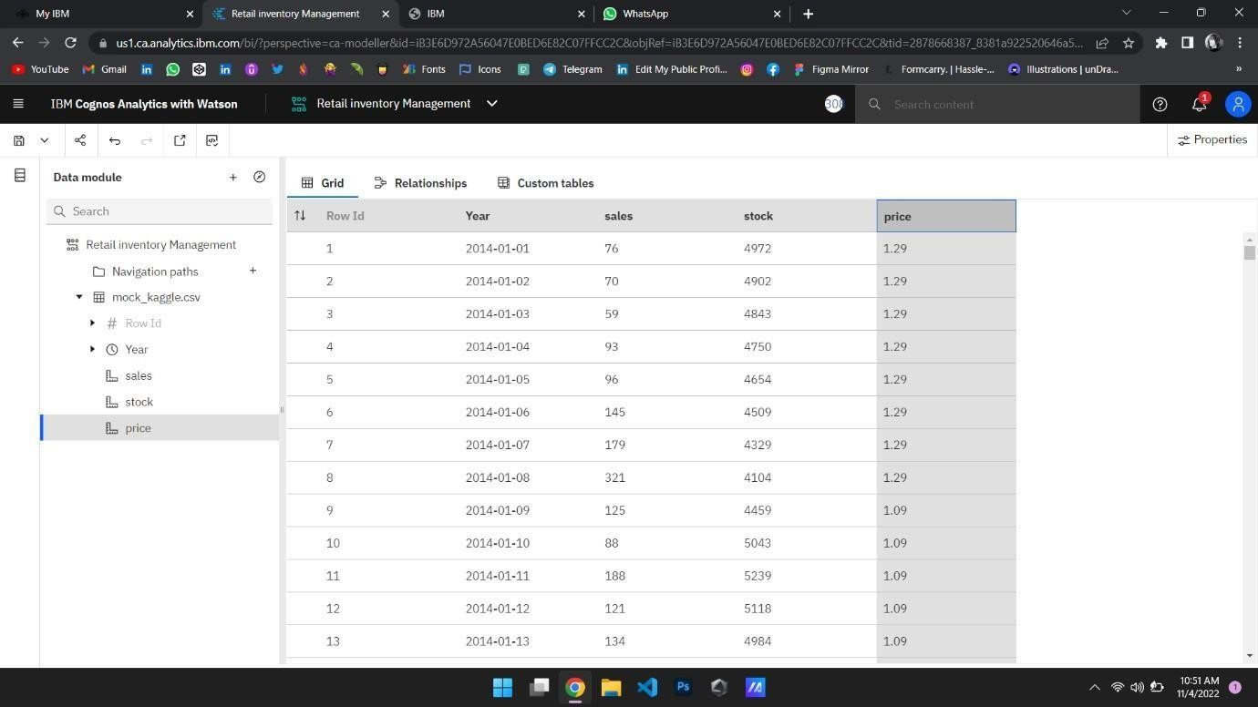

**Stock-Format Data:**

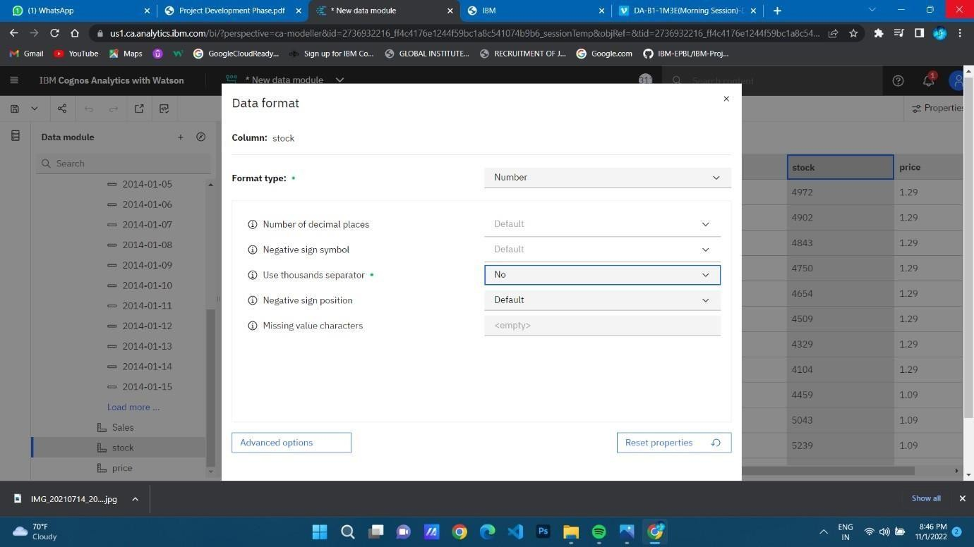

**Sales-Format Data:**

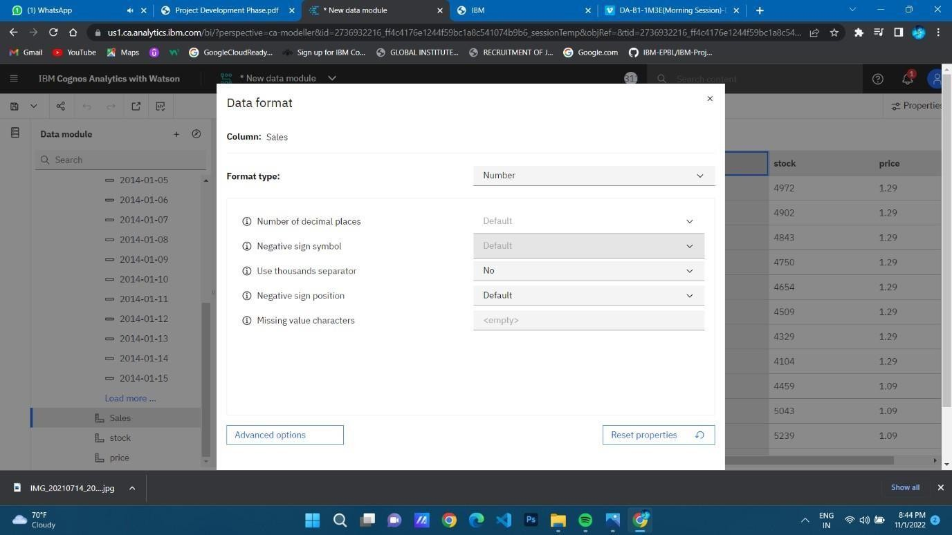

**Price-Format Data:**

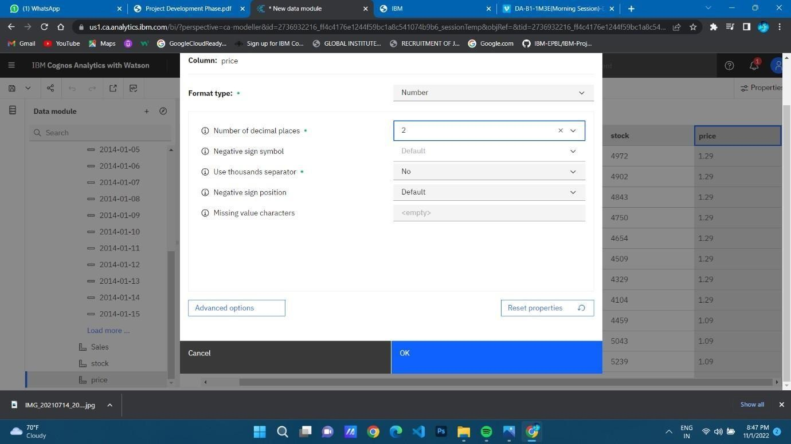

**Revenue-Format Data:**

